**Koch Herrmann - Anatagonist activities of Sox2 and Brachyury in cell fate of neuro-mesodermal progenitors - Dev Cell 2017**

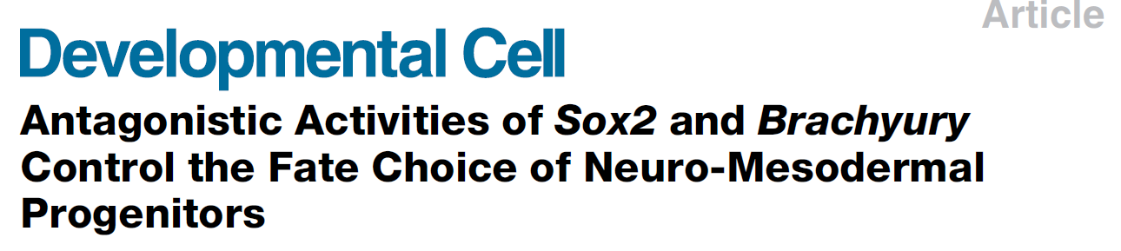

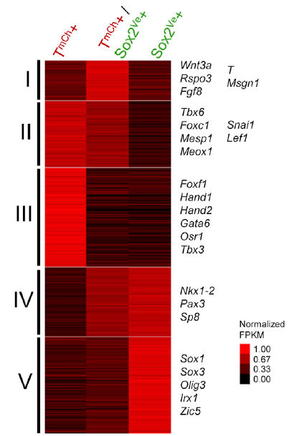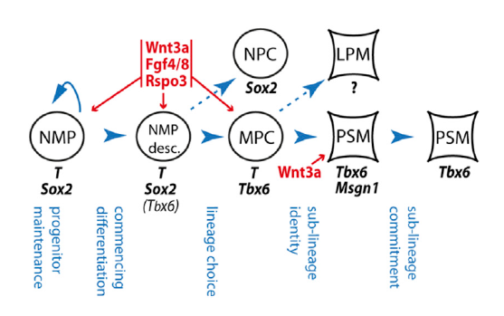

5 subgroups of cells (I,II, III, IV, V) based on NMPs and Sox2/brachyury staining

**Pijuan-Sala Gottgens – Single cell molecular map of mouse gatsrulationand early organogenesis – Nature 2019**

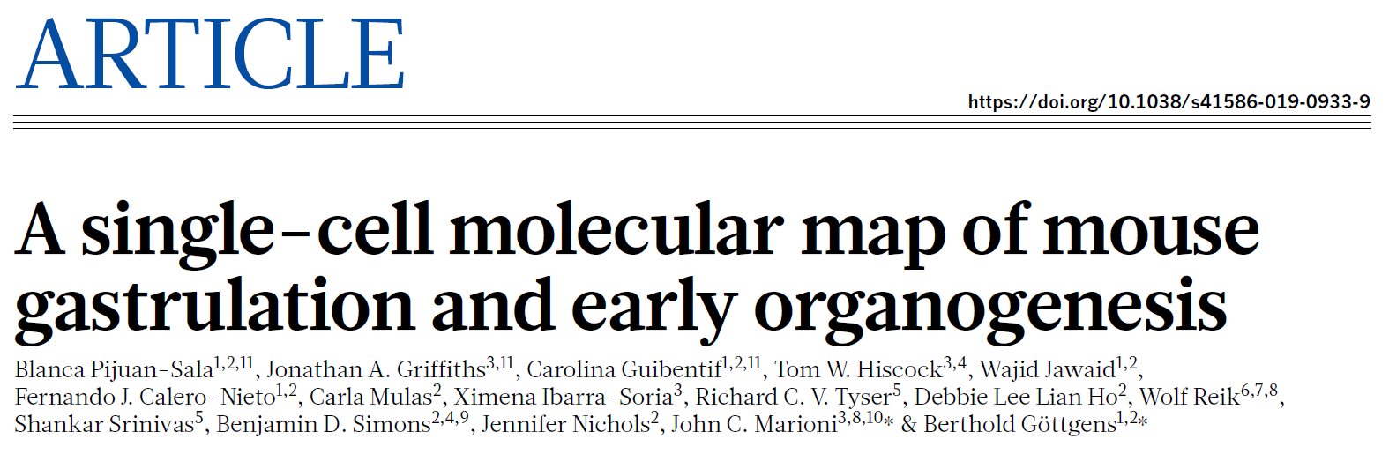

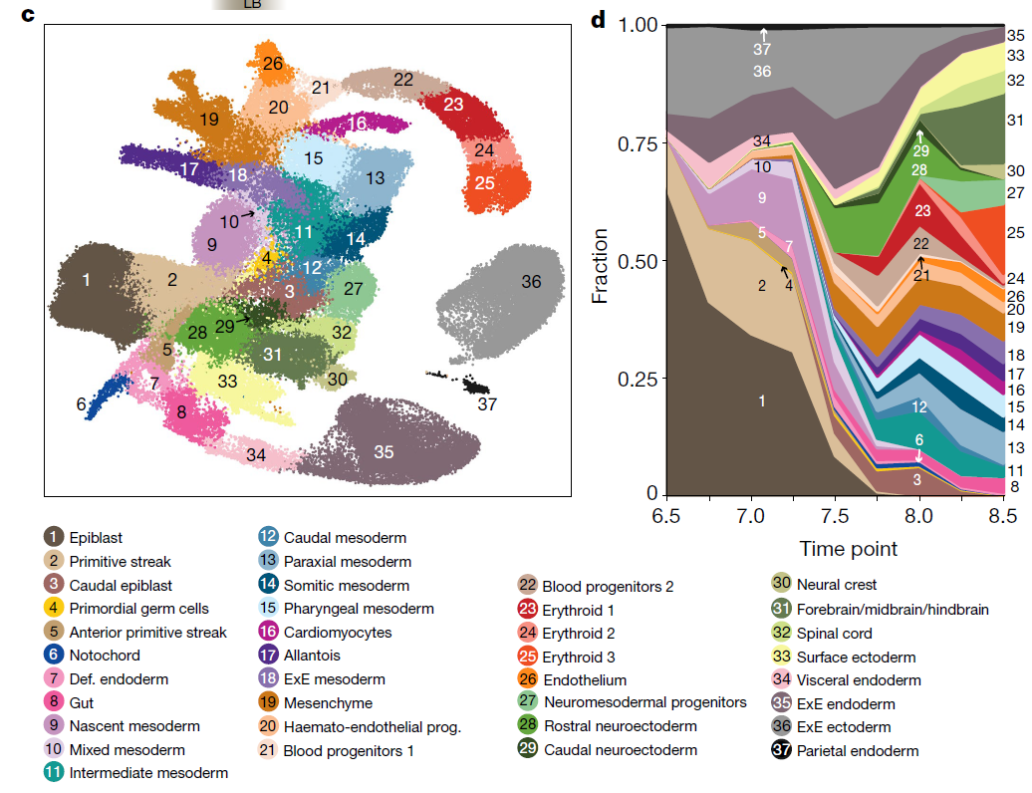

37 subgroups of cells above based on scRNA seq in mouse embryogenesis

Table of top 100 genes (not necessarily significant p-value and FDR cutoff – pulled from their website)

<https://marionilab.cruk.cam.ac.uk/MouseGastrulation2018/>

** will need to choose a p-value cutoff to apply

**Scialdone Gottgens. Resolvingearly mesoderm diversification through scRNA seq. Nature 2016**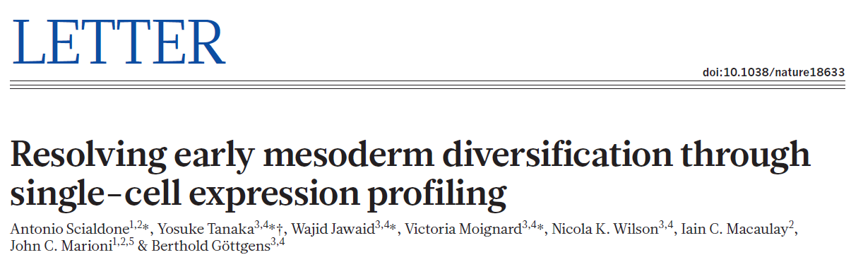

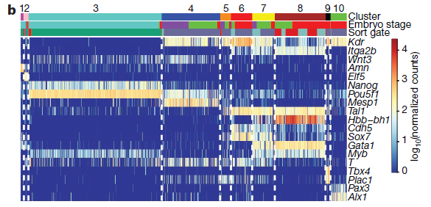

10 subgroups of cells above, but some groups have very few genes

**Brink Outdenaarden. ScRNA and transcriptomics reveal somitogenesis in gastruloids. Nature 2020.**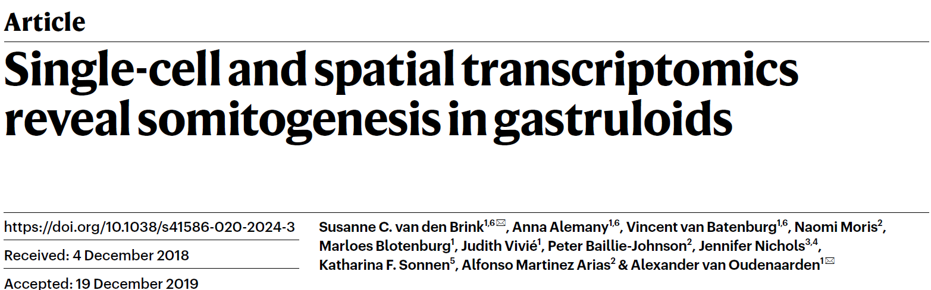

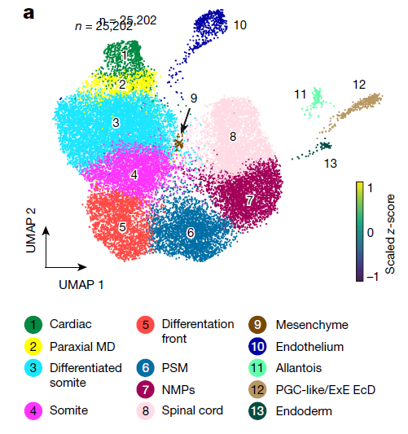

13 subgroups of cells – T is expressed in subgroups #6-#7